# **Computer Hardware Identification**

**Date:**

**Group Name:**

**Group Members (2 Max):**

In this activity, in groups of 2, you will be taking a computer apart. Using a working computer and a phone, take pictures of the components and enter a description of the component and what it does. If the computer that is being dissected does not have the component, then getting an image from the internet is acceptable. Identify and describe the following computer components:

1. Case
   * Image: 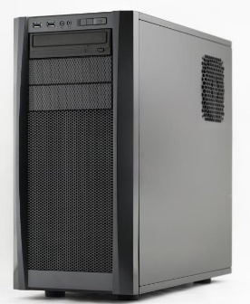
   * Description: the metal and plastic box that contains the main components of the computer, including the motherboard, central processing unit (CPU), and power supply.
   * Function: safeguards all the important and expensive parts of a PC or other computing device.
2. Motherboard
   * Image: 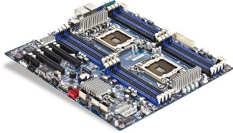
   * Description: the main printed circuit board (PCB) in a computer.
   * Function:  distributes electricity and facilitates communication between and to the central processing unit (CPU), random access memory (RAM), and any other component of the computer's hardware.
3. CPU
   * Image: 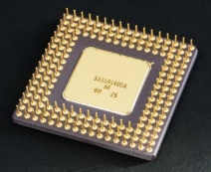
   * Description: The component of a computer system that controls the interpretation and execution of instructions.
   * Function: responds to and processes the basic instructions that drive a computer.
4. GPU
   * Image: 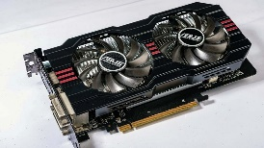
   * Description:  a specialized processor originally designed to accelerate graphics rendering.
   * Function: accelerate graphics rendering.
5. RAM
   * Image: 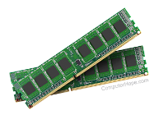
   * Description:  your computer or laptop's short-term memory.
   * Function: stores data it needs to retrieve quickly.
6. Storage Device
   * SSD vs HDD
7. Cooling
   * CPU
     1. Image:
     2. Description:
     3. Function:
   * Chassis
     1. Image:
     2. Description:
     3. Function:
8. PSU (Power Supply Unit)
   * Image:
   * Description:
   * Function:
9. Monitor
   * Image:
   * Description:
   * Function:
10. Mouse
    * Image:
    * Description:
    * Function:
11. Keyboard
    * Image:
    * Description:
    * Function: